In this guide you will find information about the following, in this order:
- Creative Accessibility
- Venue Information
- Arriving at the Venue by TTC
- Arriving by Wheel-Trans, RideShare or Taxi
- Entering and Navigating Inside the Venue
- Bathrooms and Drinking Water
- Street to Seat Support Option
- Community Dinner Location
- Seating Details
- Masks and Ventilation
- Other Accessibility Notes
- Contact Information

1. Creative Accessibility
Joy in My Ears is designed for Blind and Low-vision audiences to access events through the design of the plays or, in the case of Apocalypse Play, through Integrated Audio Descriptions. There is no in-ear audio description. Every performance is accessible for Blind and low-vision audiences.

2. Venue Information
Joy in My Ears is at Small World Centre in the Youngplace Building at 180 Shaw Street in Toronto, Ontario. Wayfinding signage is provided in Braille and Tactile labels throughout the facility. The building is on Shaw Street halfway between Queen Street and Dundas Street at the head of a T-Junction (Shaw Street and Lobb Avenue). This intersection has traffic lights and Accessible Pedestrian Signals at all four corners.
There are two entrances to the Youngplace Building. Both entrances face Shaw Street and are side-by-side, approximately 5m apart. One entrance can be accessed from a ramp that starts approximately 10m north of the intersection on Shaw Street and runs along the side of the building to the door. This entrance can also be accessed via 8 steps directly by the traffic lights on the north-west of the intersection. The second entrance also has 8 steps, is about 5m south, and is wider.
There is more detail in a later section “5. Entering and Navigating Inside the Venue” about these entrances, and navigating inside the Youngplace Building.
Here is a Google Maps Street View screenshot of the Youngplace Building:
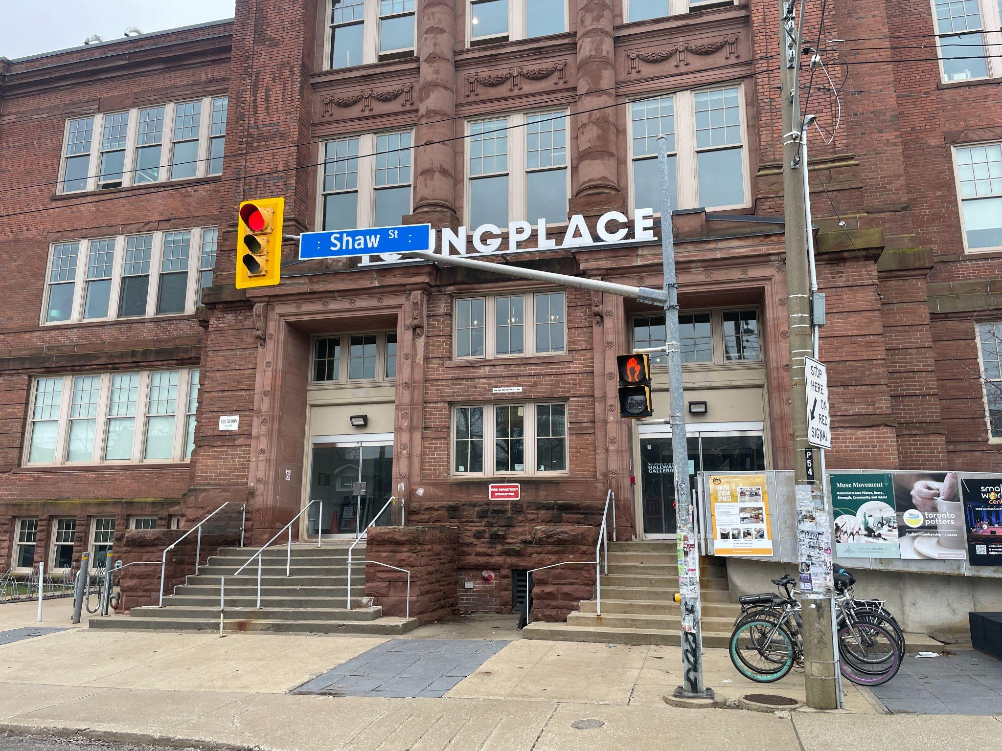
You can also visit Google StreetView on Google Maps

3. Arriving at the Venue by TTC
Access the Small World Centre in the Youngplace Building by taking the 501 Queen Streetcar, the 505 Dundas Streetcar or the 63 Ossington Bus

501 Queen Streetcar
Coming from West of the Venue, the streetcar stop number is 6850: Queen St West at Shaw St on the South side of the street. You will get off the streetcar in the middle lane of the road, and have to cross a lane of traffic to step on to the South-West corner of Queen Street West and Shaw Street. Once you are on the sidewalk, cross the intersection according to the traffic lights using the Accessible Pedestrian Signals once until you are on its North-West corner and continue North for approximately 250m, after which the entrances to Youngplace will be on your left.
Coming from East of the Venue, the streetcar stop number is 6851: Queen St West at Shaw St on the North side of the street. You will get off the streetcar in the middle lane of the road, and have to cross a traffic lane, before getting onto the sidewalk which is the North East corner of Queen Street West and Shaw Street. Once you are on the sidewalk, cross the intersection once according to the traffic lights using the Accessible Pedestrian Signals until you are on the North West corner of the intersection. Head north for approximately 250m, after which the entrances to Youngplace will be on your left.
Here is a Google Maps screenshot of the intersection showcasing the TTC stops: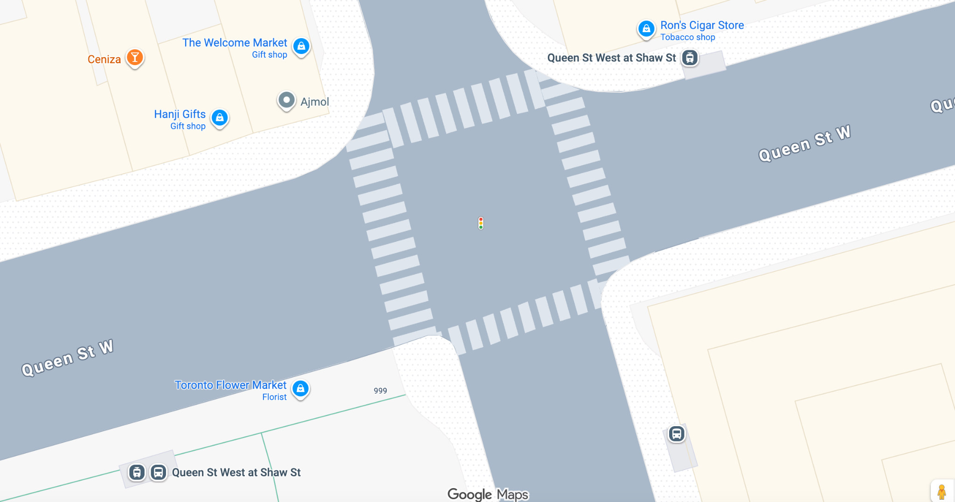
Or explore the 501 Queen Streetcar Route using this link

505 Dundas Streetcar
Coming from West of the Venue, the streetcar stop number is 2185: Dundas St West at Shaw St on the South side of the street. You will get off the streetcar in the middle lane of the road, and have to cross a lane of traffic to step on to the South-West corner of Dundas Street West and Shaw Street. Once you are on the sidewalk, walk to the intersection and turn right to head south for approximately 300m, after which the entrances to Youngplace will be on your right.
Coming from East of the Venue, the streetcar stop number is 15356: Dundas St West at Shaw St on the North side of the street. You will get off the streetcar in the middle lane of the road, and have to cross a traffic lane, before getting onto the sidewalk which is the North East corner of Dundas Street West and Shaw Street. Once you are on the sidewalk, cross the intersection twice according to the traffic lights using the Accessible Pedestrian Signals until you are on the South West corner of the intersection. Head south for approximately 300m, after which the entrances to Youngplace will be on your right.
Here is a Google Maps screenshot of the intersection showcasing the TTC stops:
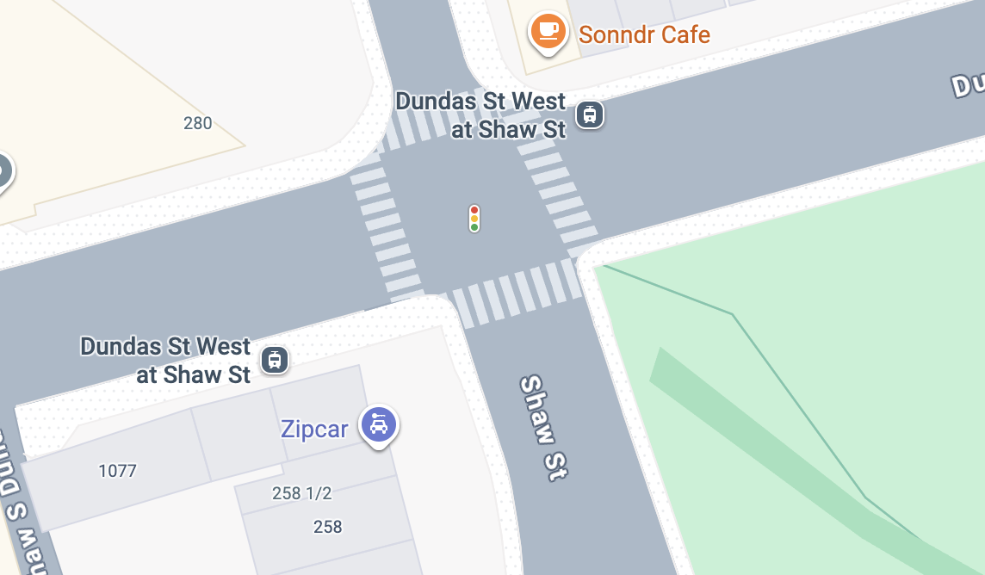
Or explore the 505 Dundas Streetcar Route using this link

63 Ossington Bus
Coming from North of the Venue, the bus stop number is 6850: Queen St West at Shaw St on the South side of the street. You will get off the bus on the sidewalk where you will be on the South-West corner of Queen Street West and Shaw Street. Once you are on the sidewalk, cross the intersection according to the traffic lights using the Accessible Pedestrian Signals once until you are on its North-West corner and continue North for approximately 250m, after which the entrances to Youngplace will be on your left.
Coming from South of the Venue, the bus stop number is 6052: Shaw St at Queen St West on the East side of Shaw street. You will get off the bus on the sidewalk where you will be on the South-East corner of Queen Street West and Shaw Street. Once you are on the sidewalk, cross the intersection twice according to the traffic lights using the Accessible Pedestrian Signals until you are on the North West corner of the intersection. Head north for approximately 250m, after which the entrances to Youngplace will be on your left.
Here is a Google Maps screenshot of the intersection showcasing the TTC stops:
Or explore the 63 Ossingston Bus Route using this link

4. Arriving by Wheel-Trans, RideShare or Taxi
When taking a RideShare or Taxi, provide the address of 180 Shaw Street for the most direct drop off location. The car should drop you off on the West side of the street. If you need a ramp, ask the car north of the intersection. If you use stairs, ask the car to drop you off as close to the intersection as possible.

5. Entering and Navigating Inside the Venue
There are two entrances to the Daniels Spectrum Building. Both entrances face Shaw Street.

The North Entrance
One entrance is closer to the North corner of the building. This entrance is accessed either via a ramp that runs along the front of the building, or by stairs that are by the North-West intersection of Shaw Street and Lobb Avenue. This entrance has a glass double door, with an automatic open button on the far left of the double door. Once you pass through the first glass double door, there is a vestibule with an elevator in front of you and stairs on your left. You can either take the elevator a single (half floor) up to the ground level or you can take the stairs (7 steps) to Level 1. Turn left down the hallway once you do either and you will see the Small World Centre on your left. Common Boots Theatre will have a table set up outside the theatre to sign you in and guide you into the space.
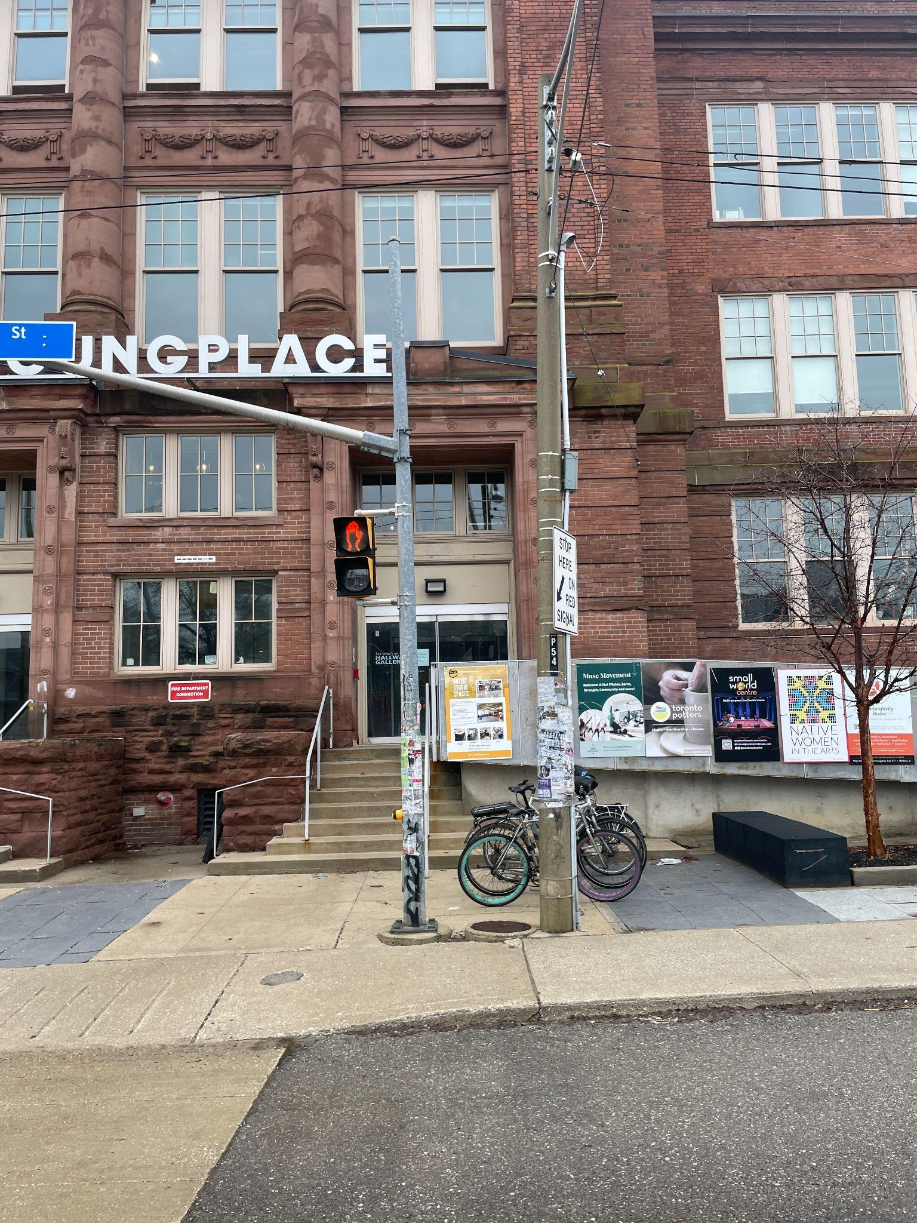
Here is a picture of the North Entrance:

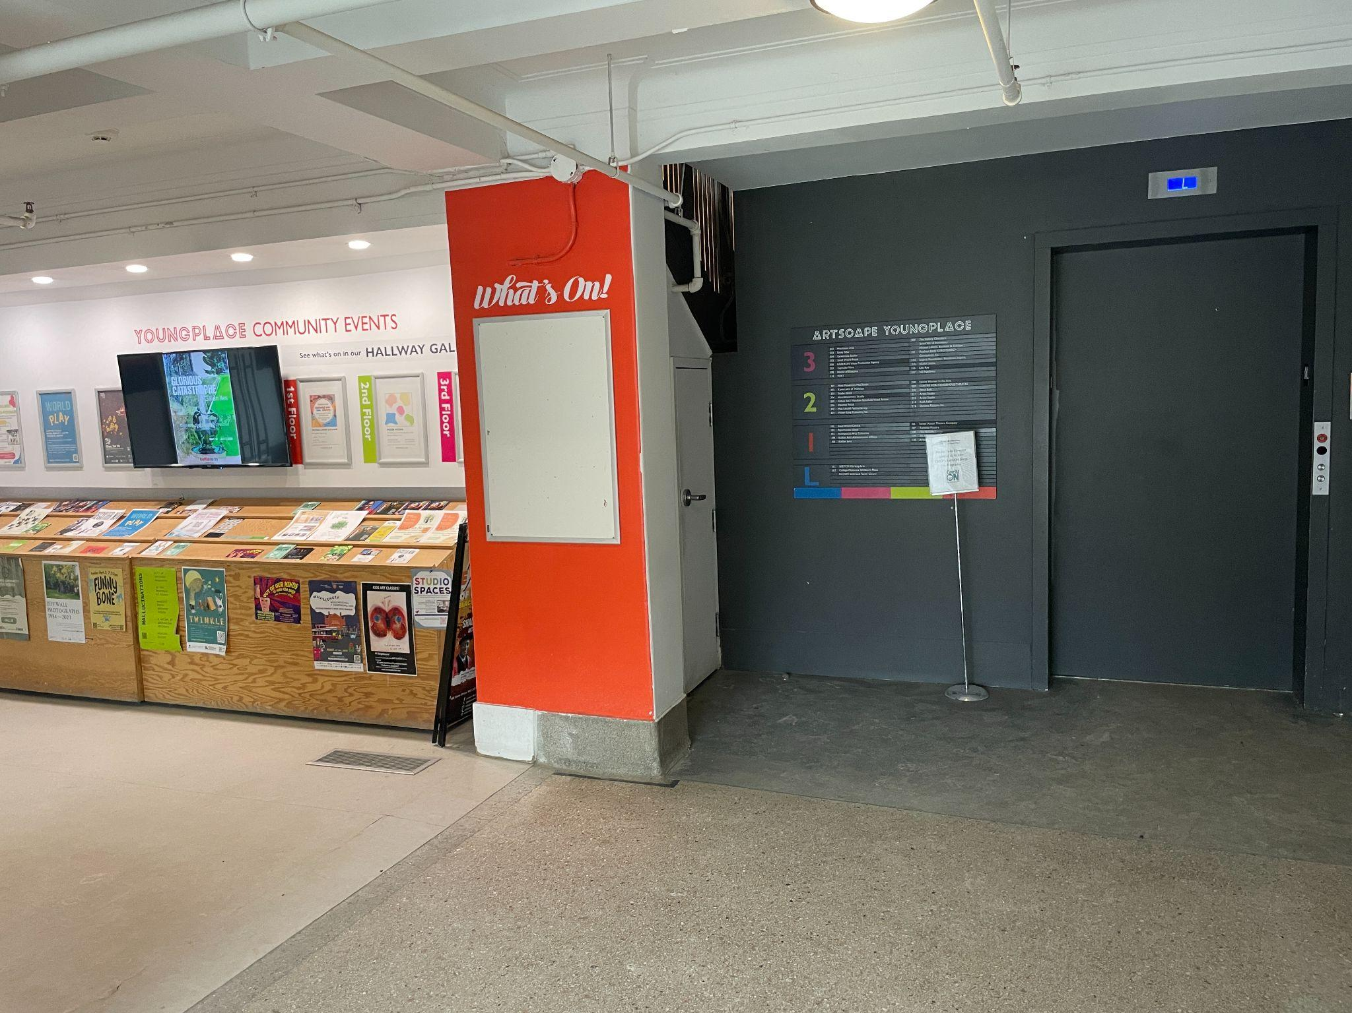
Once you enter the north entrance you can turn left to the stairs, or take the elevator to Level 1. Here is a picture of the elevator:

The South Entrance
One entrance is closer to the South corner of the building. This entrance has 8 steps up to a landing to reach the glass double door South Entrance.
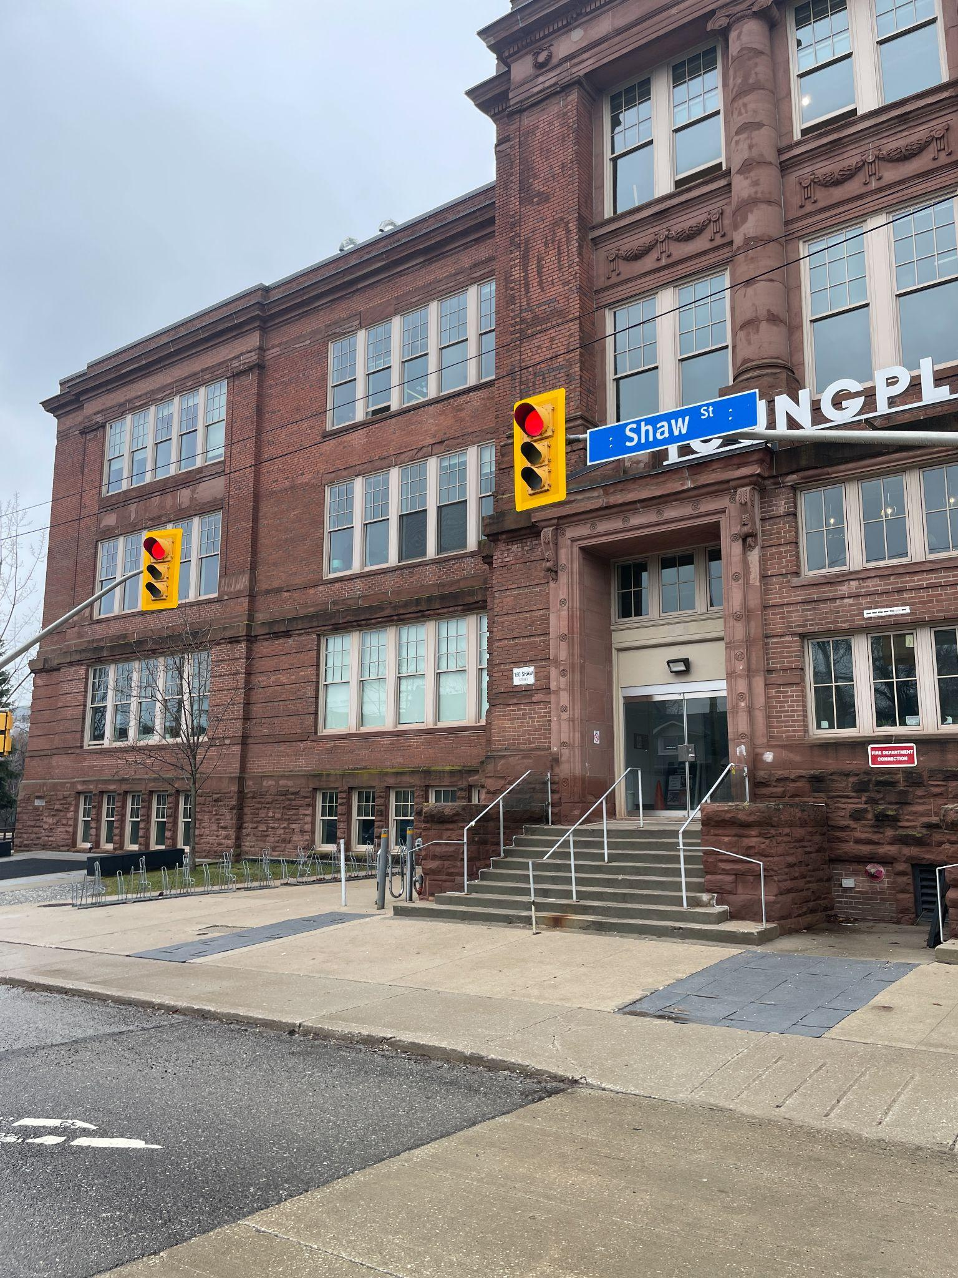
The South Entrance has glass double doors with an automatic open button approximately 3 feet high, attached to the building, on the far right side of the glass double doors. Once you pass through the first glass double door, there is a small vestibule, followed by a second set of stairs (7steps). When you ascend the second set of stairs, you will be on Level 1 of the Youngplace building. You will take a left down the hallway. Small World Centre is on your left hand side. Common Boots will have a table set up outside the theatre to sign you in and guide you into the space. Here is a picture of the South Entrance:

These are these stairs you will walk up to Level 1:

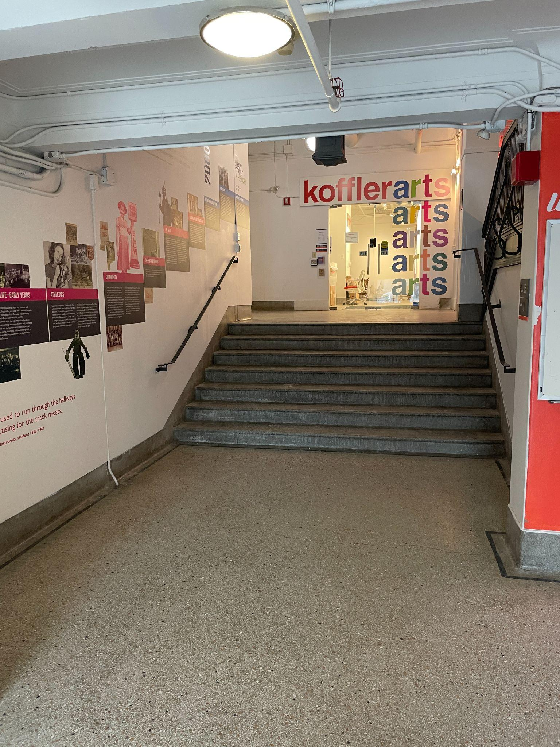

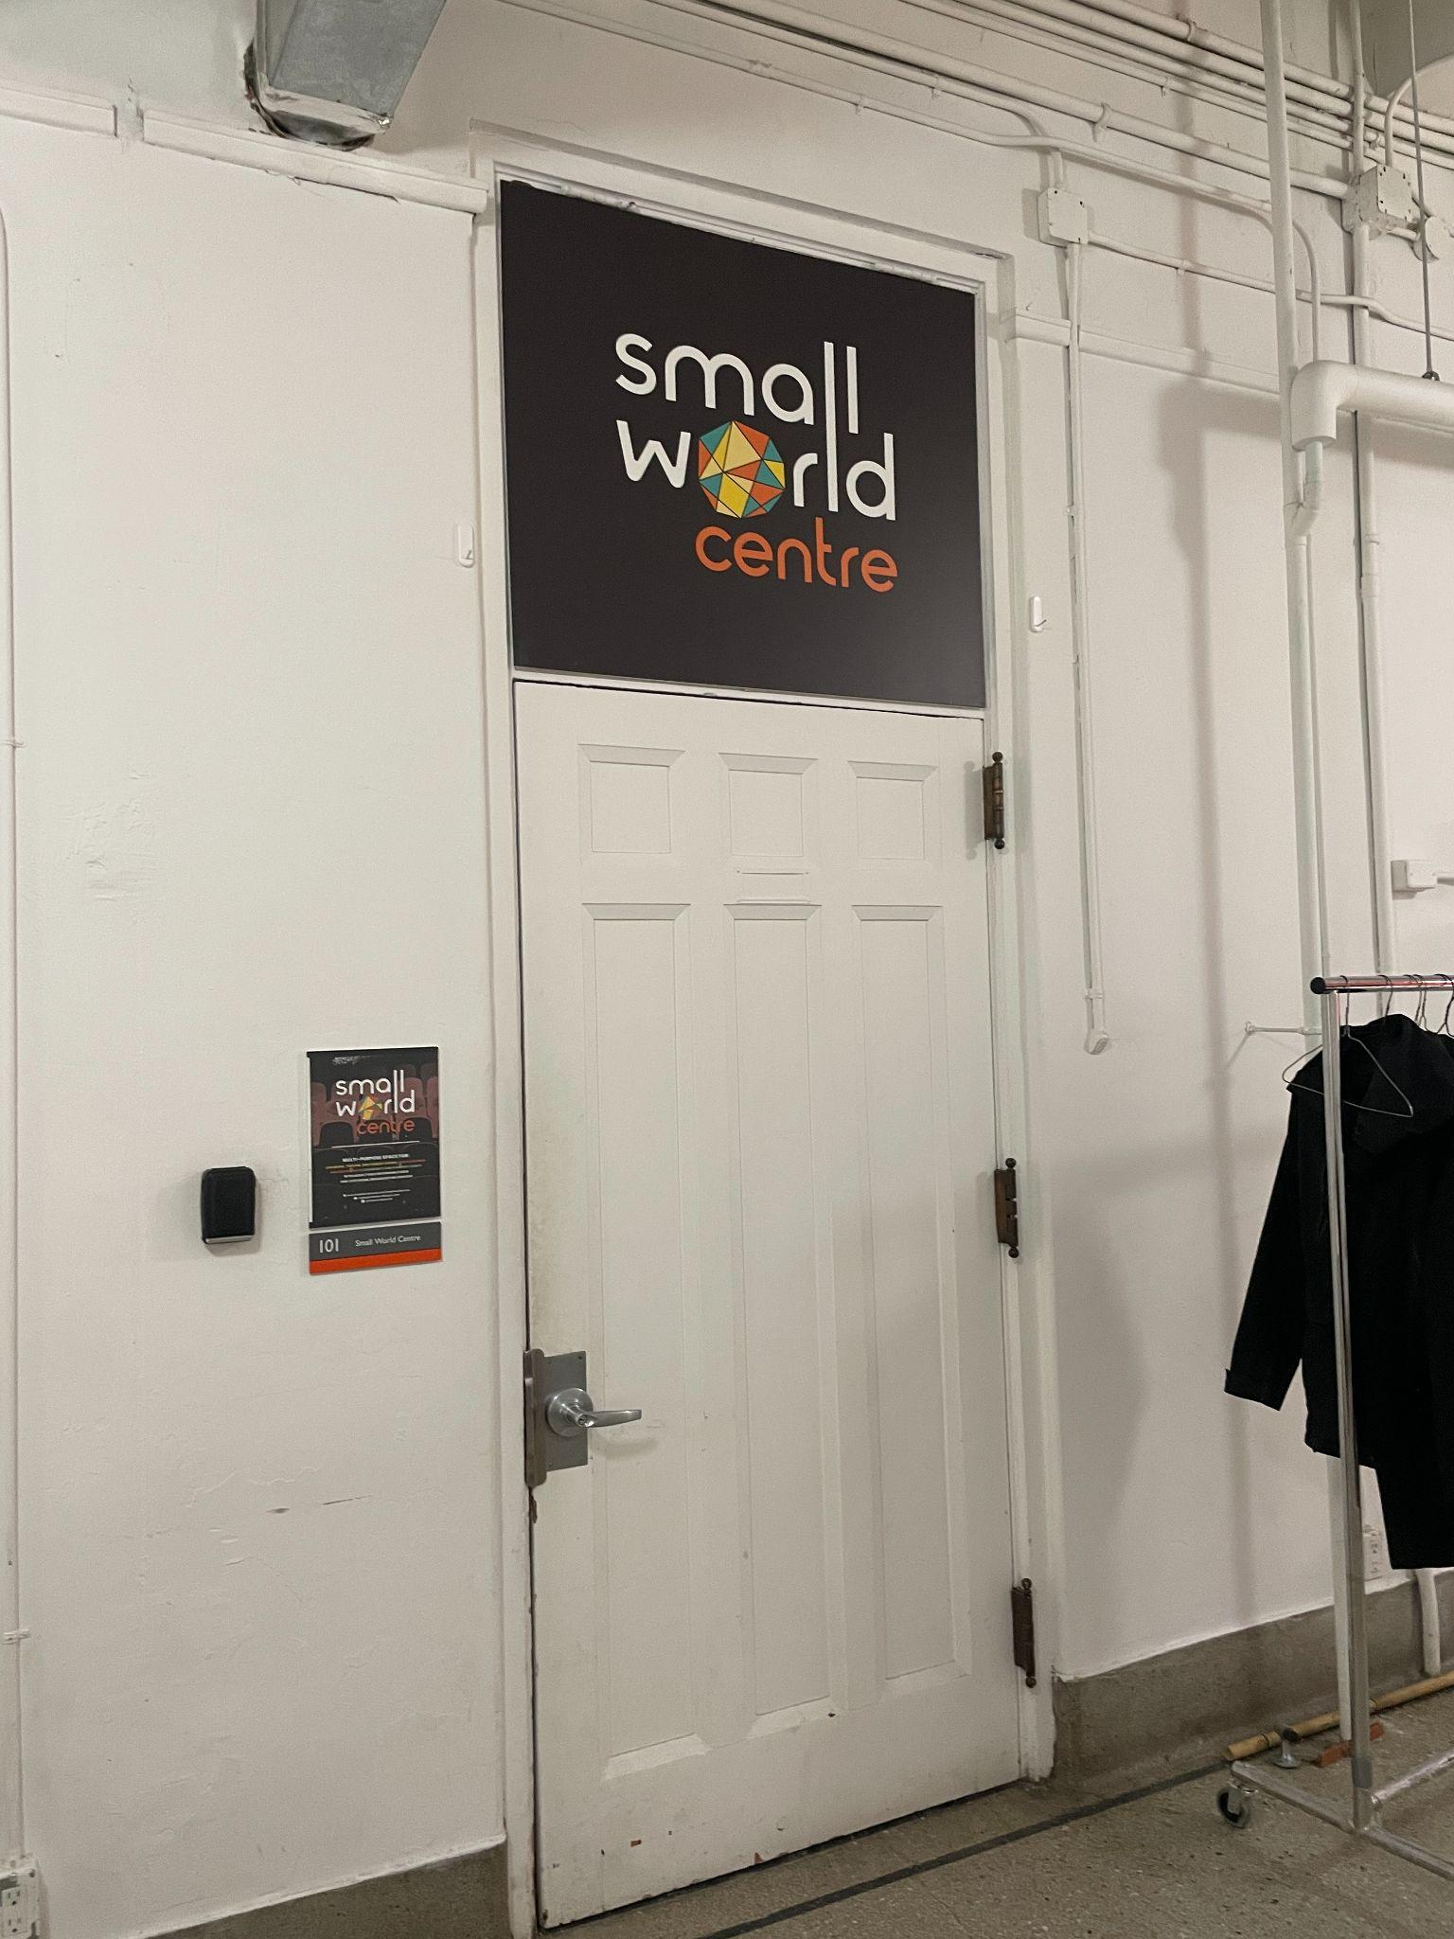
This is Small World Centre:

6. Bathrooms and Drinking Water
The Youngplace Building has gendered bathrooms with multiple stalls including an accessible stall. Water access in this building is located half-level to the cafeteria space or in the bathrooms where there is a tap and a sink to fill up water bottles.
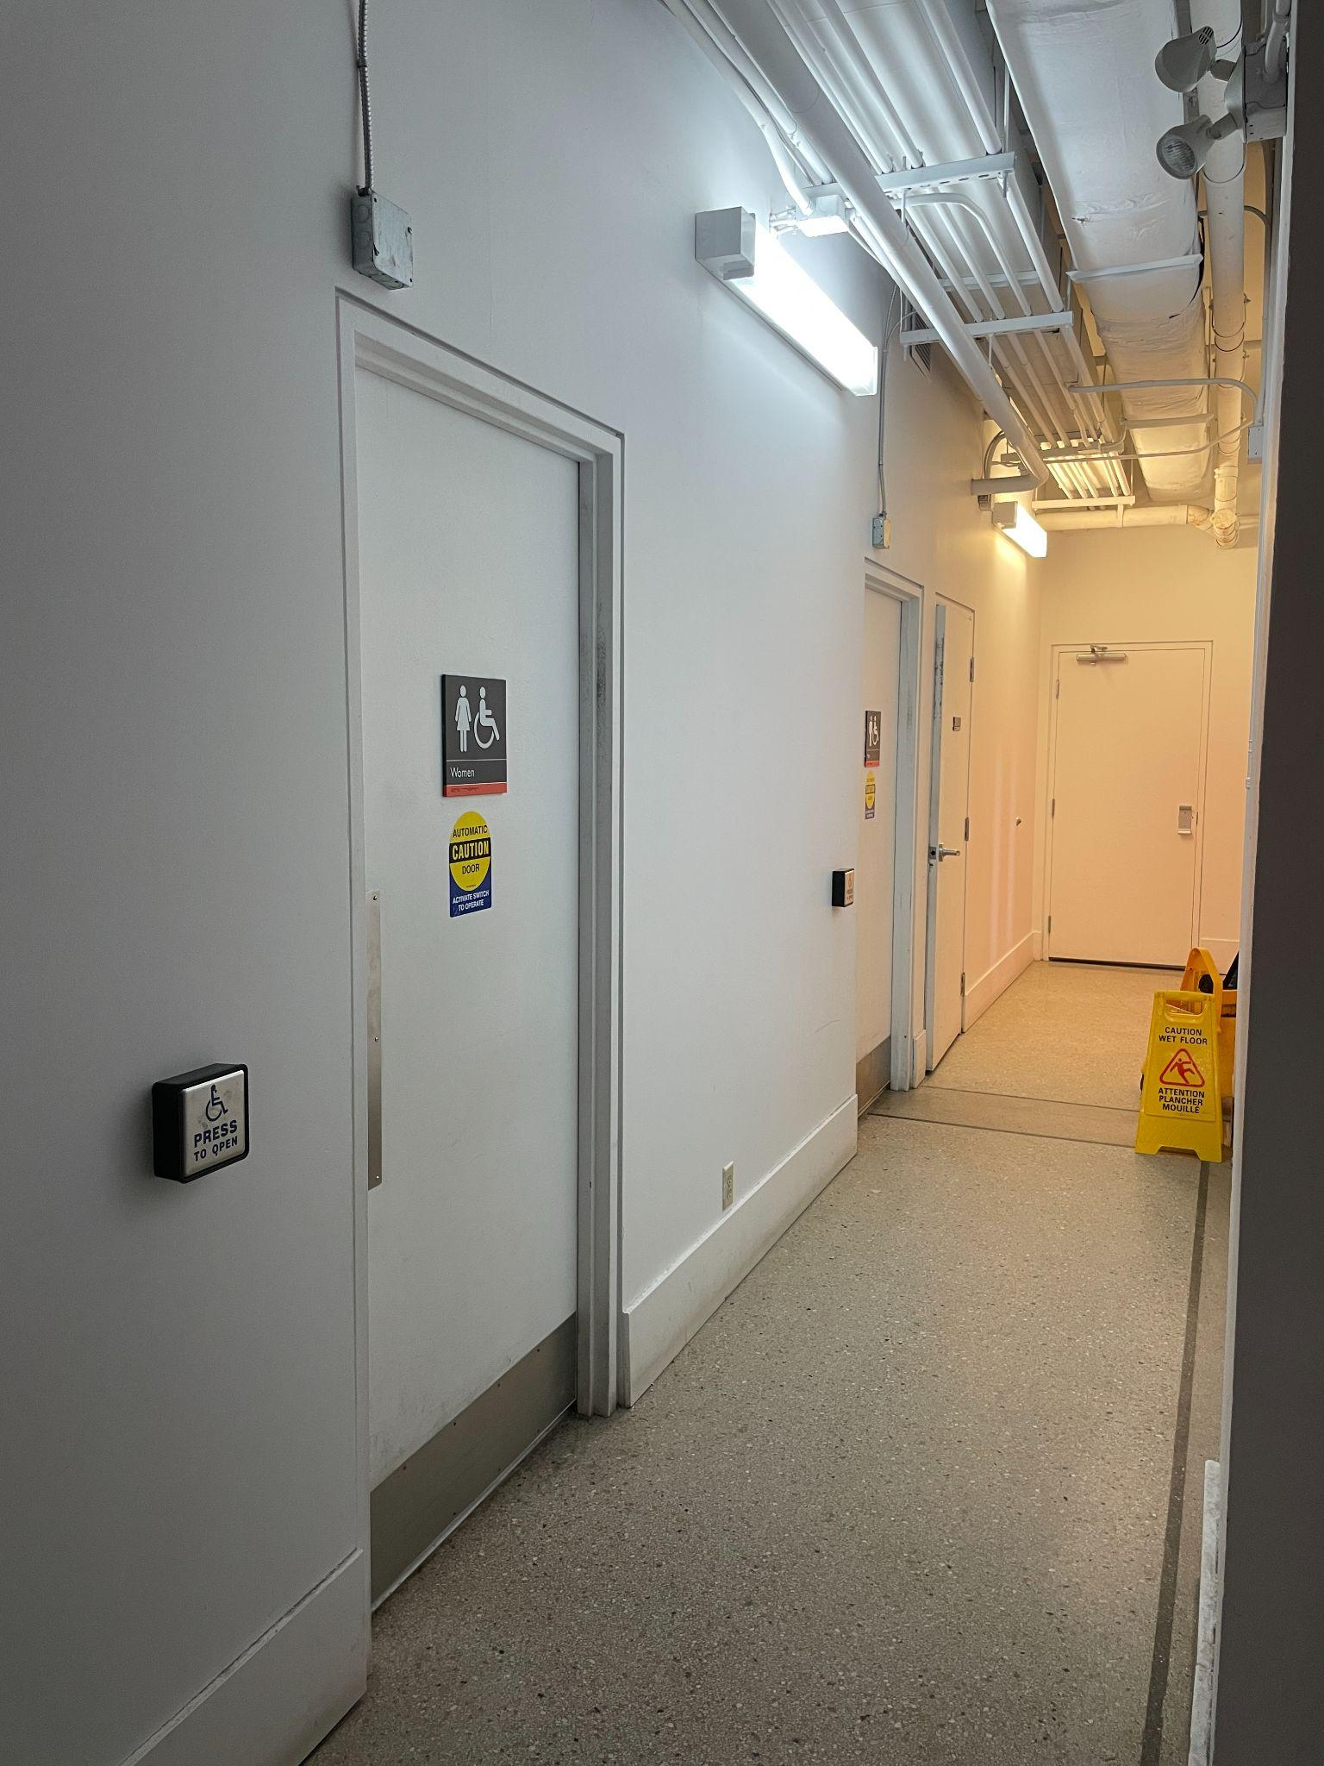
This is the hallway to the bathroom:

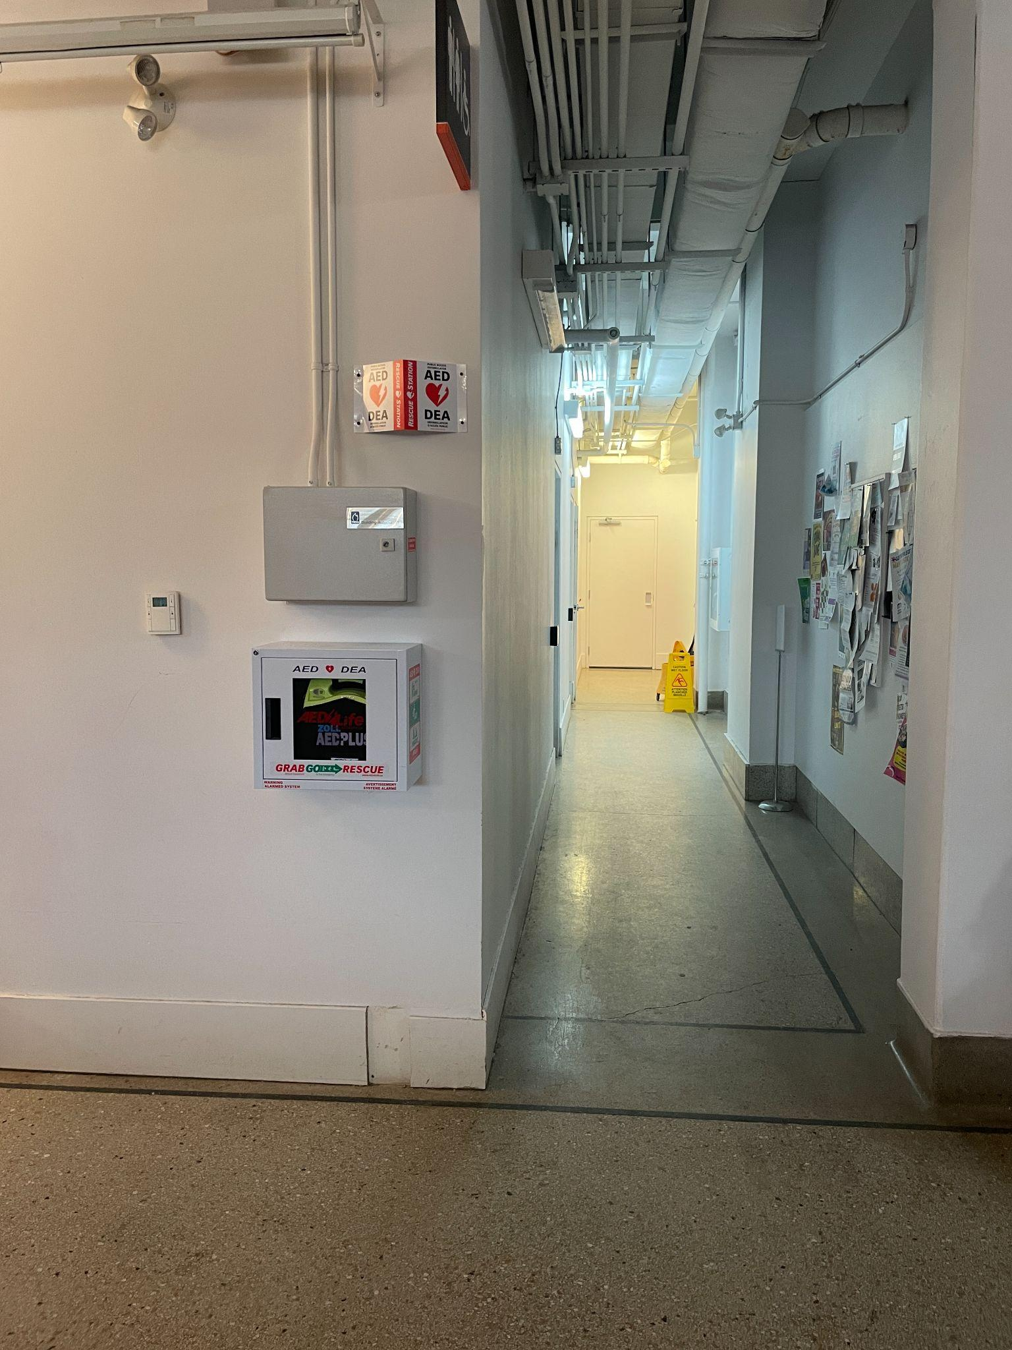
These are the bathrooms:

7. Street to Seat Support Option
When you arrive outside Youngplace, our ushers will be standing by to support you as needed. If you require assistance you can ask for their support or call Suchiththa at 647 551 1904 if there are no personnel available and we will ensure that someone comes to find you and guide/support you to the Small World Centre.

8. Community Dinner Location
The Community Dinner takes place in the cafeteria space which is a right turn straight ahead and then another right turn. You can either take the stairs to the cafeteria (10 steps, with a platform in the middle) or continue to the elevator with doors on the right hand side of the hallway.

This is the cafeteria:
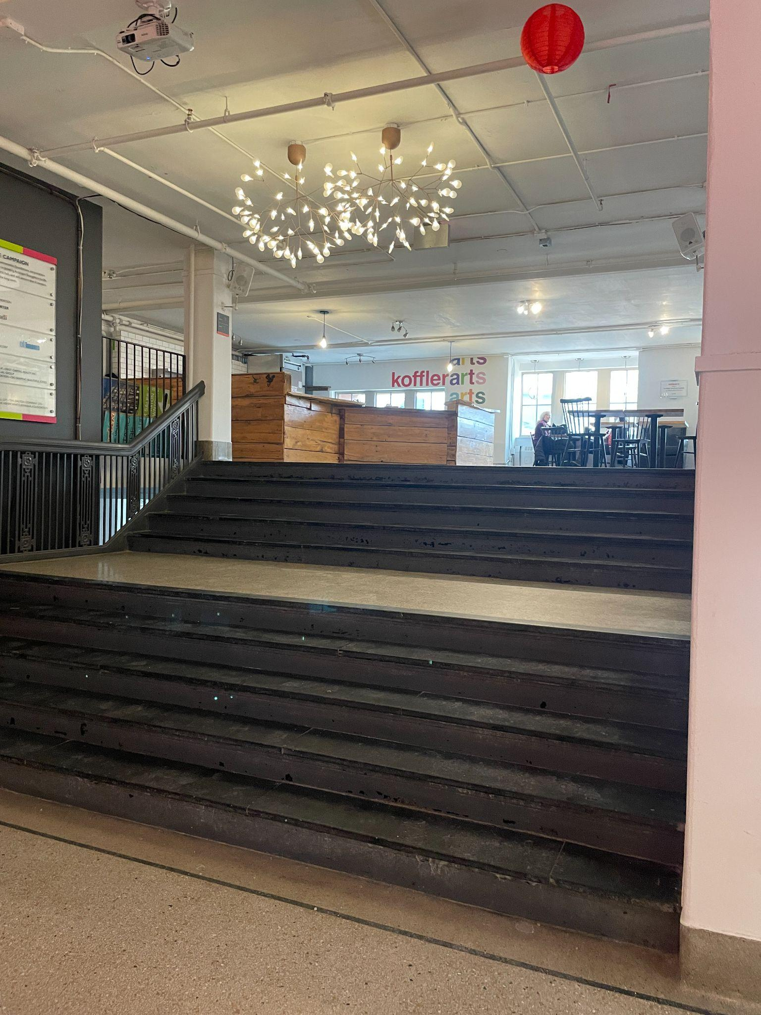

9. Seating Details
Small World Centre has bleacher-style seating as well as a flexible seating area with space for wheelchairs, service dogs and movable folding chairs. There are 2 areas of seating in total.

10. Masks
We are not offering mask-only performances. Patrons are welcome to wear masks, and our performance space will have a sign that says “we are a mask-friendly space”. We will have a box of masks on site.

11. Other Accessibility Notes
Unfortunately we’re unable to provide ASL-interpreted performances.

12. Further Contact Information
Email foh@commonbootstheatre.ca for any questions.
You have reached the end of this guide – thank you! Last updated on Mar 20, 2026

